**Name:ATHIRA BIJU**

**Roll No: 4**

**Batch: B**

**Date: 06/06/22**

**NETWORKING & SYSTEM ADMINISTRATION LAB**

**Experiment No.: 4**

**Aim**

Wireshark

**Procedure**

1. **sudo apt install wireshark :**Wireshark’s latest version has been added to the APT, you can download and install.

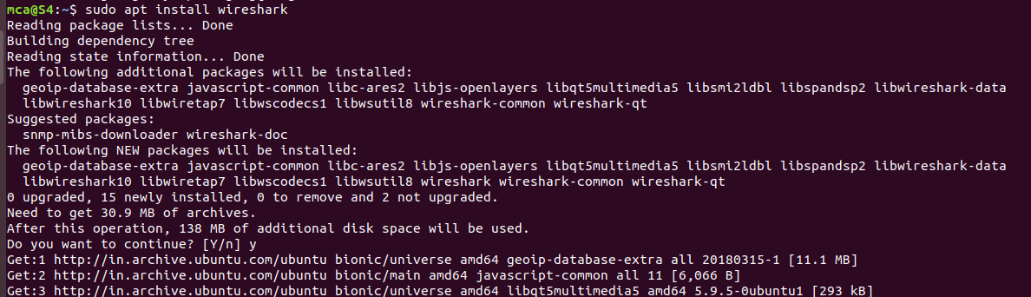

1. **Sudoadduser $USER wireshark :**



1. **Sudowireshark :**To start wireshark application.



1. **Capturing packet using wireshark :** List of interfaces that you can capture packets to and from.There are many types of interfaces you can monitor using Wireshark, for example,**Wired**, **Wireless,** USB and many external devices. You can choose to show specific types of interfaces in the welcome screen from the marked section of the screenshot below:

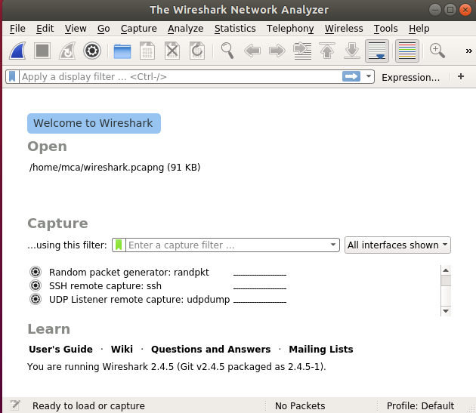

 Many packets were captured

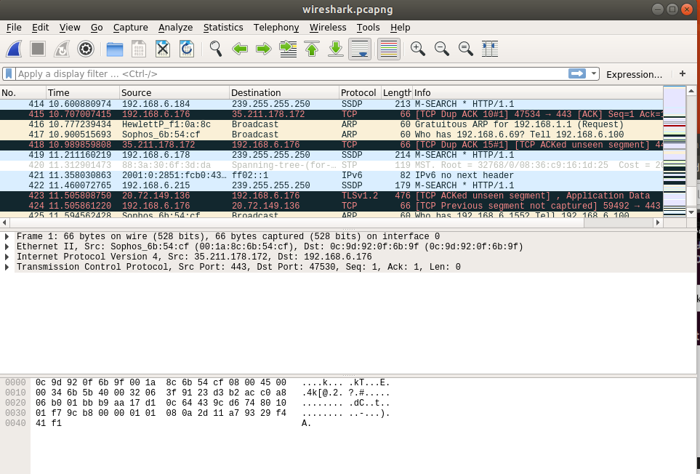

1. **Sudo apt –get install netcat :**Installing netcat.

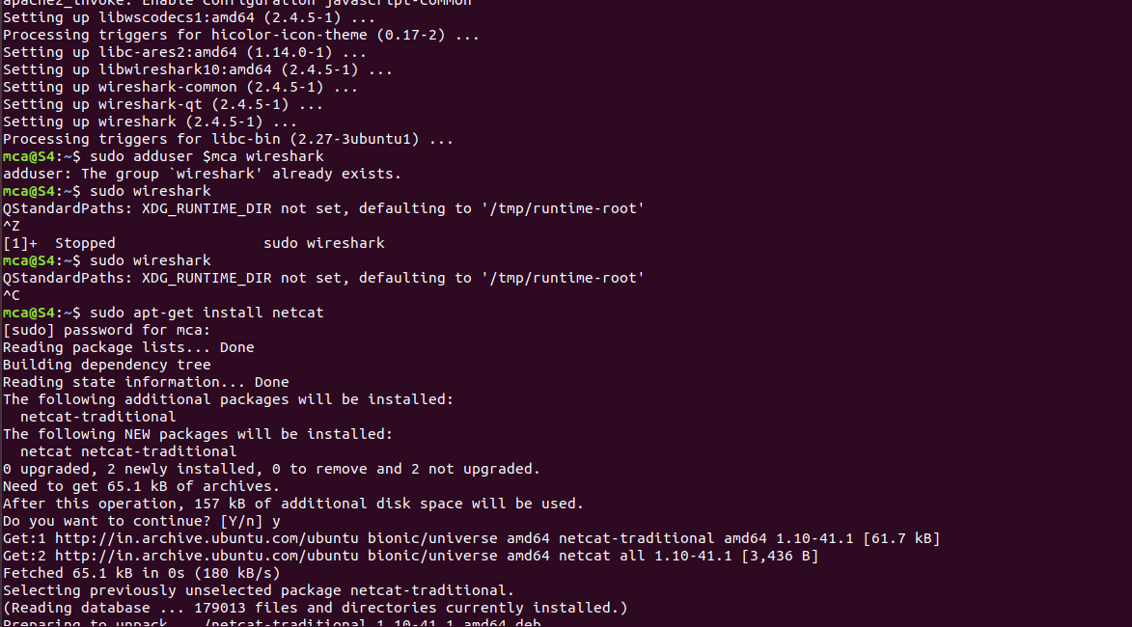

1. **nc –l –p 1234 :**To set up the server using Netcat in listening mode. We will use port 12345 and will specify the port number with the -p option.

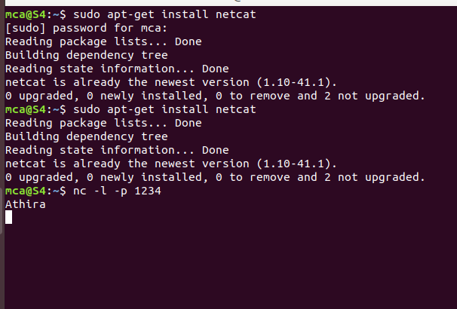

1. **nc localhost 1234 :**The client needs the server ip to connect to it. My server and my client are on the same machine so I use localhost for the hostname. The command ‘nc hostname port’ puts Netcat in client mode and connects to the specified hostname on the specified port.

